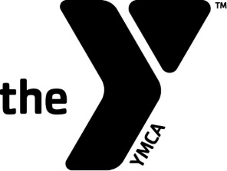
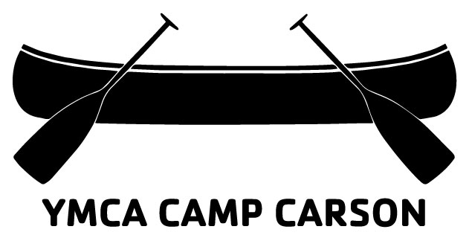
Service Corps Program Application
Summer 2021

Name: ____________________________________________________________________________________________________________________
Email Address: __________________________________________________________________________________________________________
Cell Phone: ______________________________________________________________________________________________________________

Please type a response to the questions below. And then return to Ryan Meeks via email at rmeeks@ymcacampcarson.org
- Why are you interested in participating in the Service Corps Program?

- What is one thing you are looking forward to learning this summer?

- Why do you feel you will be a great role model and leader for our campers?

- Anything else you would like us to know? Your experience with kids, your extracurricular activities?

- What questions do you have about Service Corps Program?

